BAHRIA UNIVERSITY, ISLAMABAD
Department of Computer Science



INTRODUCTION TO DATA SCIENCE LAB

─────────────────────────────

LAB JOURNAL # 02

─────────────────────────────

SUBMITTED BY  Umm-e-Habiba Imran  01-134241-048  6TH A | SUBMITTED TO  Maryam Aslam  Fall 2026  10TH September 2026

Q1.
Dataset (Exam Scores of 20 students, skewed to the right):
data = [5, 7, 8, 6, 5, 9, 10, 12, 15, 18, 20, 22, 25, 30, 35, 40, 42, 45, 50, 60]
- (a) Compute mean, median, and mode using Python.
- (b) Plot a histogram of the dataset.
- (c) Explain which measure best represents the dataset and why.
# TASK 1:
from scipy import stats
import numpy as np
import matplotlib.pyplot as plt
data = [5, 7, 8, 6, 5, 9, 10, 12, 15, 18, 20, 22, 25, 30, 35, 40, 42, 45, 50, 60]
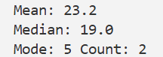

mean = np.mean(data)
median = np.median(data)
mode = stats.mode(data, keepdims=True)

print("Mean:", mean)
print("Median:", median)
print("Mode:", mode.mode[0], "Count:", mode.count[0])

plt.hist(data, bins = 10, edgecolor="black")
plt.title("Distribution of Data")
plt.xlabel("Exam Score")
plt.ylabel("Number of Students")
plt.show()
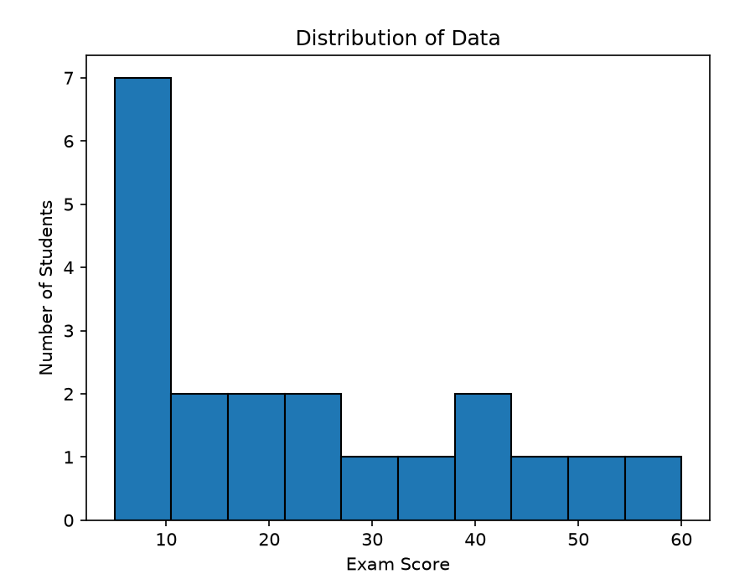
Median is the best measure as it does not change by inputting high or small values.

Q2.
Datasets:
dataset_A = [50, 52, 51, 49, 50, 51, 50, 49, 52, 50] # low variance
dataset_B = [10, 30, 50, 70, 90, 110, 130, 150, 170, 190] # high variance
- (a) Compute variance, standard deviation, and range for both datasets.
- (b) Use box plots to compare the spreads.
- (c) Explain why the mean is the same but spread is different.
dataset_A = [50, 52, 51, 49, 50, 51, 50, 49, 52, 50] # low variance
dataset_B = [10, 30, 50, 70, 90, 110, 130, 150, 170, 190] # high variance

variance_A = np.var(dataset_A, ddof=0)
std_dev_A = np.sqrt(variance_A)
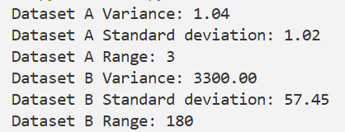
range_A = np.max(dataset_A) - np.min(dataset_A)
print(f"Dataset A Variance: {variance_A:.2f}")
print(f"Dataset A Standard deviation: {std_dev_A:.2f}")
print(f"Dataset A Range: {range_A}")

variance_B = np.var(dataset_B, ddof=0)
std_dev_B = np.sqrt(variance_B)
range_B = np.max(dataset_B) - np.min(dataset_B)
print(f"Dataset B Variance: {variance_B:.2f}")
print(f"Dataset B Standard deviation: {std_dev_B:.2f}")
print(f"Dataset B Range: {range_B}")

data = [dataset_A, dataset_B]
plt.boxplot(data, labels=['Dataset A', 'Dataset B'], patch_artist=True)
plt.show()
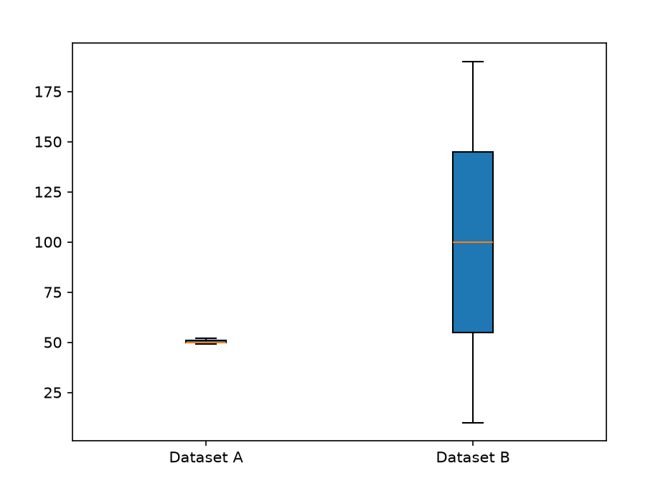
The mean is the same because both datasets have the same average value. However, their spread is different because Dataset A has values that are very close to the mean, while Dataset B has values that are widely spread out. Therefore, Dataset B has a higher variance, standard deviation, and range.

Q3.
Dataset: 500 students’ exam marks (randomly generated normal distribution).
import numpy as np
np.random.seed(42)
marks = np.random.normal(loc=65, scale=12, size=500)
- (a) Plot a histogram of marks.
- (b) Overlay the normal distribution curve on the histogram.
- (c) Comment on how closely the data follows normal distribution.
import numpy as np
import matplotlib.pyplot as plt
from scipy.stats import norm

np.random.seed(42)
marks = np.random.normal(loc=65, scale=12, size=500)
plt.hist(marks, bins=20, density=True, edgecolor="black")

x = np.linspace(min(marks), max(marks), 100)
y = norm.pdf(x, loc=65, scale=12)

plt.plot(x, y)
plt.title("Distribution of Marks")
plt.xlabel("Marks")
plt.ylabel("Density")

plt.show()

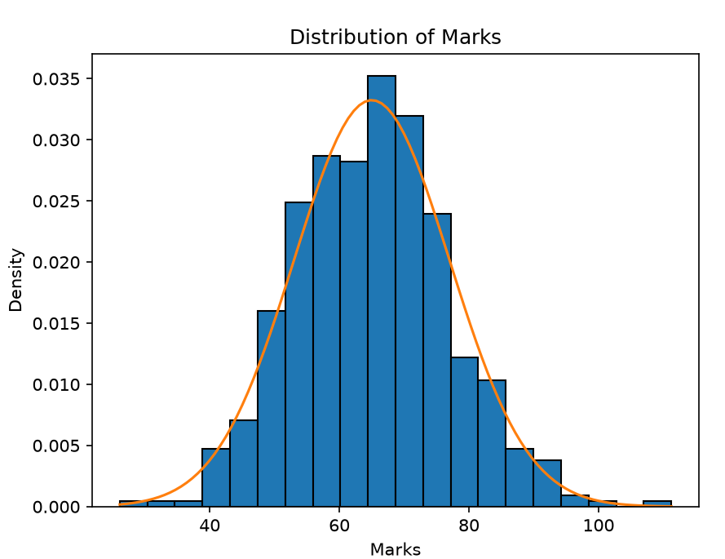
The data closely follows a normal distribution. The histogram is approximately bell-shaped and symmetric around the mean of 65. The normal distribution curve also closely matches the histogram, with only small differences due to random variation.

Q4.
# Dataset A: Study hours vs Exam scores (positive correlation)
study_hours = [2, 3, 4, 5, 6, 7, 8, 9, 10]
exam_scores = [50, 55, 60, 65, 70, 72, 78, 85, 88]
# Dataset B: Random noise values (no correlation)
x_random = [1, 2, 3, 4, 5, 6, 7, 8, 9]
y_random = [15, 88, 42, 7, 63, 29, 91, 54, 38]
- (a) Plot scatter plots for both datasets.
- (b) Compute Pearson correlation coefficient for both.
- (c) Interpret the results.
import matplotlib.pyplot as plt
from scipy.stats import pearsonr
study_hours = [2, 3, 4, 5, 6, 7, 8, 9, 10]
exam_scores = [50, 55, 60, 65, 70, 72, 78, 85, 88]
x_random = [1, 2, 3, 4, 5, 6, 7, 8, 9]
y_random = [15, 88, 42, 7, 63, 29, 91, 54, 38]
plt.scatter(study_hours, exam_scores)
plt.title("Study Hours vs Exam Scores")
plt.show()
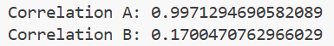
plt.scatter(x_random, y_random)
plt.title("Random Data")
plt.show()
print("Correlation A:", pearsonr(study_hours, exam_scores)[0])
print("Correlation B:", pearsonr(x_random, y_random)[0])

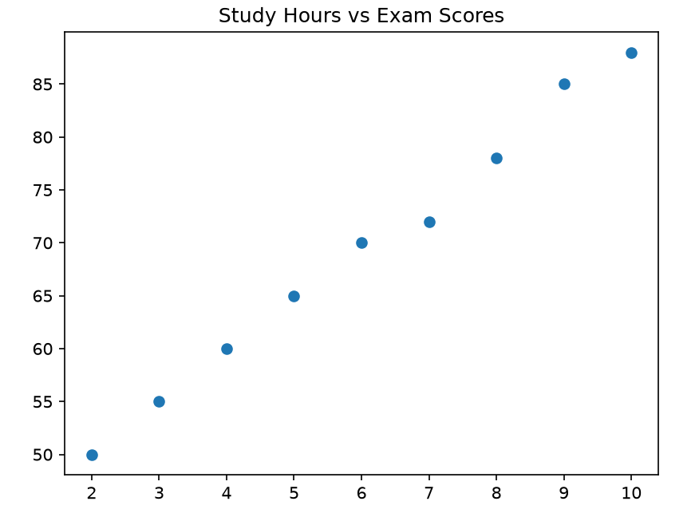
Dataset A has a strong positive correlation, meaning students who study more hours tend to have higher exam scores. Dataset B has almost no correlation, meaning there is no meaningful relationship between the two variables.

Q5.
Datasets (Monthly Salaries in 3 Departments):
dept_A = [40000, 42000, 45000, 46000, 47000, 48000, 49000, 52000, 53000, 54000]
dept_B = [30000, 32000, 35000, 36000, 37000, 42000, 45000, 46000, 47000, 50000]
dept_C = [25000, 26000, 27000, 28000, 29000, 50000, 52000, 55000, 60000, 65000]
- (a) Create box plots for the three departments.
- (b) Identify which department has the largest IQR and which has outliers.
- (c) Discuss implications for HR salary adjustments.
import numpy as np
import matplotlib.pyplot as plt
dept_A = [40000, 42000, 45000, 46000, 47000, 48000, 49000, 52000, 53000, 54000]
dept_B = [30000, 32000, 35000, 36000, 37000, 42000, 45000, 46000, 47000, 50000]
dept_C = [25000, 26000, 27000, 28000, 29000, 50000, 52000, 55000, 60000, 65000]
data = [dept_A, dept_B, dept_C]
plt.boxplot(data, labels=['Department A', 'Department B', 'Department C'],
patch_artist=True)
plt.title("Monthly Salaries of Three Departments")
plt.ylabel("Salary")
plt.show()
q1_A = np.percentile(dept_A, 25)
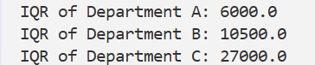
q3_A = np.percentile(dept_A, 75)
iqr_A = q3_A - q1_A
q1_B = np.percentile(dept_B, 25)
q3_B = np.percentile(dept_B, 75)
iqr_B = q3_B - q1_B
q1_C = np.percentile(dept_C, 25)
q3_C = np.percentile(dept_C, 75)
iqr_C = q3_C - q1_C
print("IQR of Department A:", iqr_A)
print("IQR of Department B:", iqr_B)
print("IQR of Department C:", iqr_C)
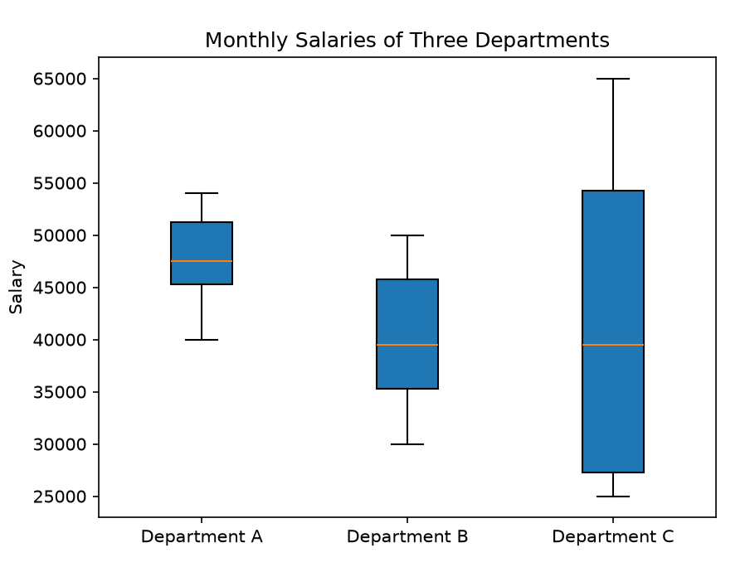

Q6.
Dataset: Survey of 100 people
responses = {"Product_A": 60, "Product_B": 40}
Tasks:
- (a) Perform a binomial test to check if more than 50% prefer Product A.
- (b) Compute p-value and interpret the result at 5% significance.
- (c) Calculate a 95% confidence interval for Product A’s preference proportion.

import numpy as np
from scipy import stats
responses = {"Product_A": 60, "Product_B": 40}
result = stats.binomtest(responses["Product_A"], n=100,
p=0.5, alternative='greater')
p_value = result.pvalue
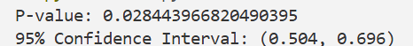
print("P-value:", p_value)
p_hat = responses["Product_A"] / 100
standard_error = np.sqrt((p_hat * (1 - p_hat)) / 100)
lower = p_hat - 1.96 * standard_error
upper = p_hat + 1.96 * standard_error
print(f"95% Confidence Interval: ({lower:.3f}, {upper:.3f})")

Q7.
Dataset (Student Exam Scores):
scores = [45, 48, 50, 52, 54, 55, 58, 60, 62, 65, 68, 70, 72, 74, 76, 78, 80, 82, 85, 90]
Tasks:
- (a) Compute Q1, Q2 (Median), Q3 for the dataset.
- (b) Calculate the 10th percentile and 90th percentile.
- (c) Plot a box plot to verify results visually.
import numpy as np
import matplotlib.pyplot as plt
scores = [45, 48, 50, 52, 54, 55, 58, 60, 62, 65,
68, 70, 72, 74, 76, 78, 80, 82, 85, 90]

# Part (a): Quartiles
q1 = np.percentile(scores, 25)
q2 = np.percentile(scores, 50)
q3 = np.percentile(scores, 75)
print("Q1:", q1)
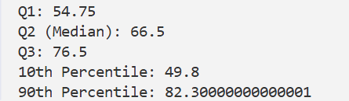
print("Q2 (Median):", q2)
print("Q3:", q3)

# Part (b): Percentiles
p10 = np.percentile(scores, 10)
p90 = np.percentile(scores, 90)

print("10th Percentile:", p10)
print("90th Percentile:", p90)

# Part (c): Box Plot
plt.boxplot(scores, patch_artist=True)
plt.title("Student Exam Scores")
plt.ylabel("Scores")
plt.show()

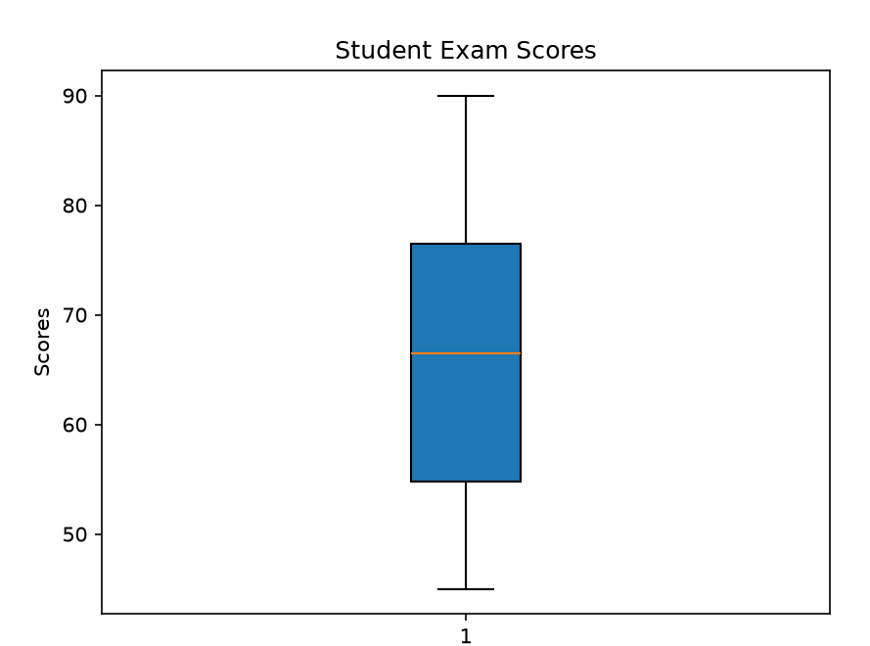

Q8.
Datasets (Exam Scores of Two Classes):
class_X = [65, 70, 68, 74, 72, 80, 85, 60, 78, 69]
class_Y = [55, 60, 58, 62, 65, 70, 68, 72, 75, 59]
Tasks:
- (a) Compute mean, median, mode, variance, and standard deviation for both classes.
- (b) Use histograms to compare their score distributions.
- (c) Interpret which class performed better and which had more variation.
import numpy as np
from scipy import stats
import matplotlib.pyplot as plt
class_X = [65, 70, 68, 74, 72, 80, 85, 60, 78, 69]
class_Y = [55, 60, 58, 62, 65, 70, 68, 72, 75, 59]

# Part (a): Class X
mean_X = np.mean(class_X)
median_X = np.median(class_X)
mode_X = stats.mode(class_X, keepdims=True)
variance_X = np.var(class_X, ddof=0)
std_X = np.sqrt(variance_X)
print("Class X")
print("Mean:", mean_X)
print("Median:", median_X)
if mode_X.count[0] == 1:
print("Mode: No mode")
else:
print("Mode:", mode_X.mode[0])
print(f"Variance: {variance_X:.2f}")
print(f"Standard Deviation: {std_X:.2f}")

# Class Y
mean_Y = np.mean(class_Y)
median_Y = np.median(class_Y)
mode_Y = stats.mode(class_Y, keepdims=True)
variance_Y = np.var(class_Y, ddof=0)
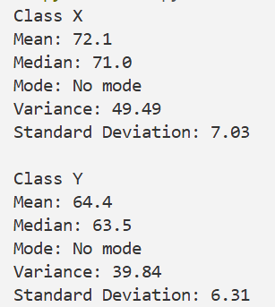
std_Y = np.sqrt(variance_Y)
print("\nClass Y")
print("Mean:", mean_Y)
print("Median:", median_Y)
if mode_Y.count[0] == 1:
print("Mode: No mode")
else:
print("Mode:", mode_Y.mode[0])
print(f"Variance: {variance_Y:.2f}")
print(f"Standard Deviation: {std_Y:.2f}")
# Part (b): Histogram of Class X
plt.hist(class_X, bins=5, edgecolor='black')
plt.title("Distribution of Class X Scores")
plt.xlabel("Scores")
plt.ylabel("Number of Students")
plt.show()
# Histogram of Class Y
plt.hist(class_Y, bins=5, edgecolor='black')
plt.title("Distribution of Class Y Scores")
plt.xlabel("Scores")
plt.ylabel("Number of Students")
plt.show()
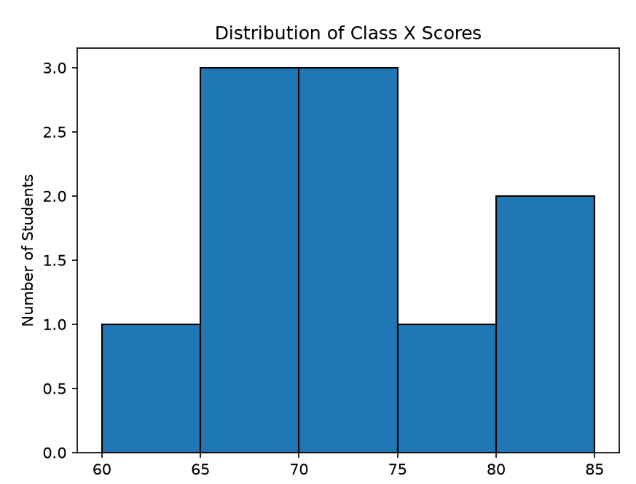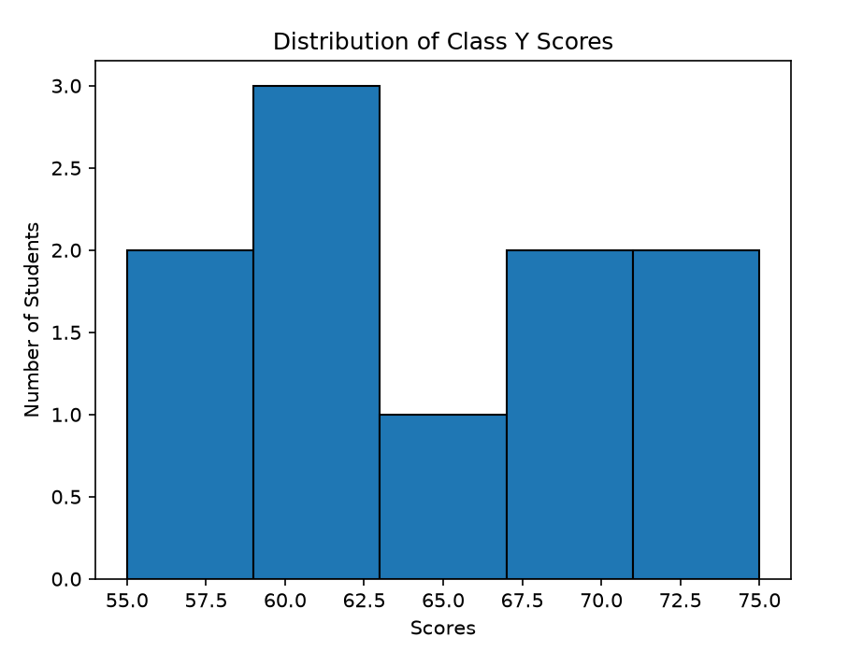

Q9.
Dataset (Advertising spend vs Sales):
ad_spend = [10, 20, 30, 40, 50, 60, 70, 80, 90, 100] # in $1000
sales = [25, 28, 35, 40, 45, 50, 60, 68, 75, 85] # in $1000
Tasks:
- (a) Create a scatter plot of ad spend vs sales.
- (b) Compute the correlation coefficient.
- (c) Explain if higher ad spending really leads to higher sales.
import numpy as np
import matplotlib.pyplot as plt

ad_spend = [10, 20, 30, 40, 50, 60, 70, 80, 90, 100]
sales = [25, 28, 35, 40, 45, 50, 60, 68, 75, 85]
# Part (a): Scatter Plot
plt.scatter(ad_spend, sales)
plt.title("Advertising Spend vs Sales")
plt.xlabel("Advertising Spend ($1000)")
plt.ylabel("Sales ($1000)")
plt.show()
# Part (b): Correlation
correlation = np.corrcoef(ad_spend, sales)[0, 1]
print(f"Correlation Coefficient: {correlation:.2f}")

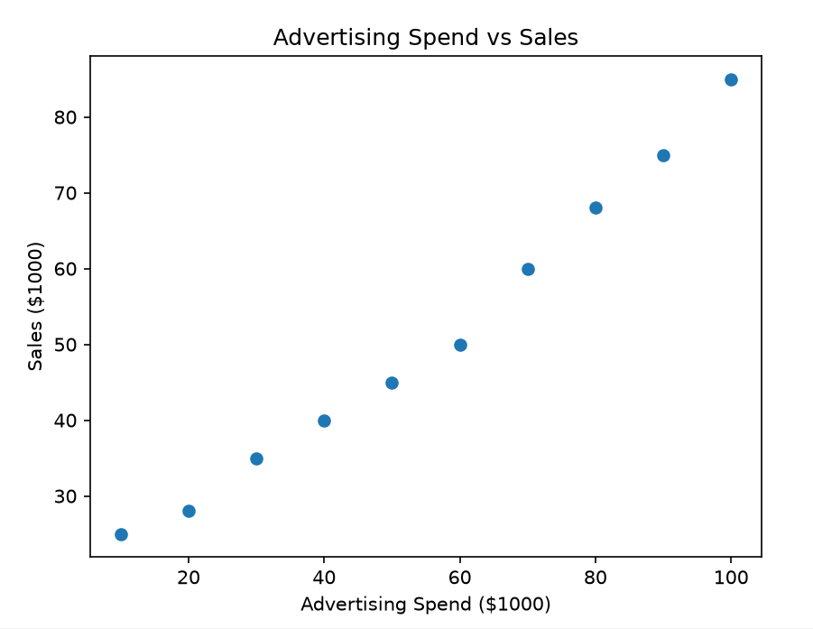

Q10.
Dataset: Out of 100 students, 58 passed and 42 failed.
pass_count = 58
fail_count = 42
Tasks:
- (a) Perform a binomial hypothesis test to check if the pass rate is significantly greater than 50%.
- (b) Compute the p-value and interpret at a 5% significance level.
- (c) Plot a histogram of pass/fail outcomes to visualize distribution.
from scipy import stats
import matplotlib.pyplot as plt
pass_count = 58
fail_count = 42
# Part (a): Binomial Hypothesis Test
result = stats.binomtest(pass_count, n=100,
p=0.5, alternative='greater')
p_value = result.pvalue
print("P-value:", p_value)
# Part (c): Histogram
outcomes = [1] * pass_count + [0] * fail_count
plt.hist(outcomes, bins=2, edgecolor='black')
plt.title("Pass and Fail Distribution")
plt.xlabel("Outcome (0 = Fail, 1 = Pass)")
plt.ylabel("Number of Students")
plt.show()

